1. [SELECT](http://localhost/phpmyadmin/url.php?url=https://dev.mysql.com/doc/refman/8.0/en/select.html" \t "mysql_doc) nama, stok, expired, petunjuk\_pemakaian.dewasa FROM `obat`

JOIN petunjuk\_pemakaian ON id\_petunjuk\_pemakaian = petunjuk\_pemakaian.id

ORDER BY expired ASC;

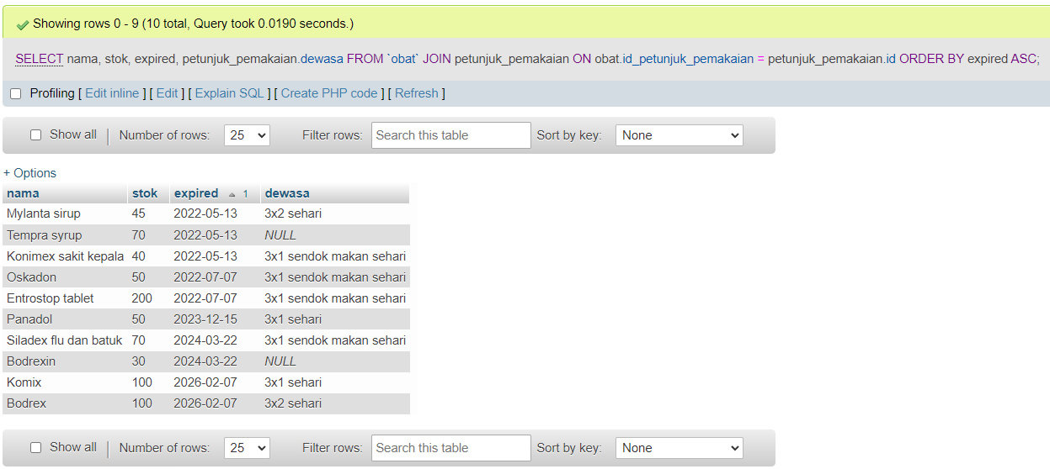

1. [SELECT](http://localhost/phpmyadmin/url.php?url=https://dev.mysql.com/doc/refman/8.0/en/select.html) id\_pelanggan, id\_obat, harga, usia

FROM `detail\_orders`

JOIN `pelanggan` ON id\_pelanggan = pelanggan.id ORDER BY id\_obat DESC;

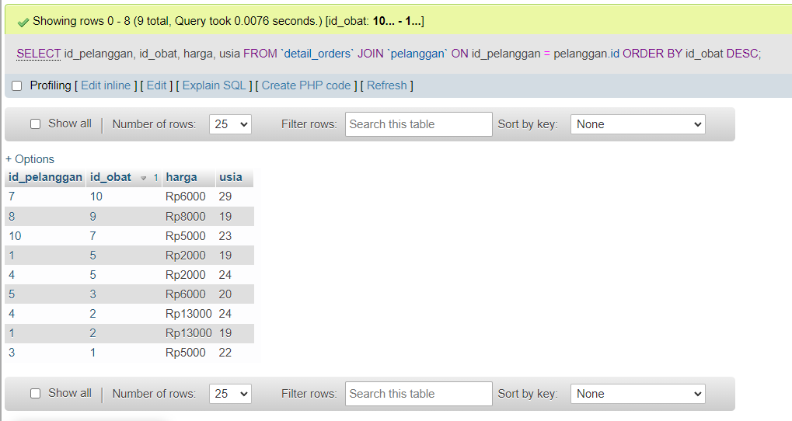

1. SELECT id\_obat, harga, nama\_pelanggan FROM `detail\_orders`

JOIN `pelanggan` ON id\_pelanggan = pelanggan.id ORDER BY id\_obat ASC;

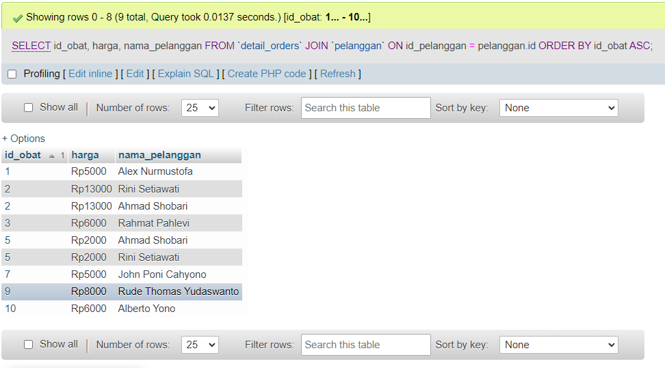

1. [SELECT](http://localhost/phpmyadmin/url.php?url=https://dev.mysql.com/doc/refman/8.0/en/select.html) id\_pelanggan, id\_obat, harga, nama\_pelanggan FROM `detail\_orders`

[RIGHT](http://localhost/phpmyadmin/url.php?url=https://dev.mysql.com/doc/refman/8.0/en/string-functions.html#function_right) JOIN pelanggan ON id\_pelanggan = pelanggan.id ORDER BY id\_pelanggan ASC;

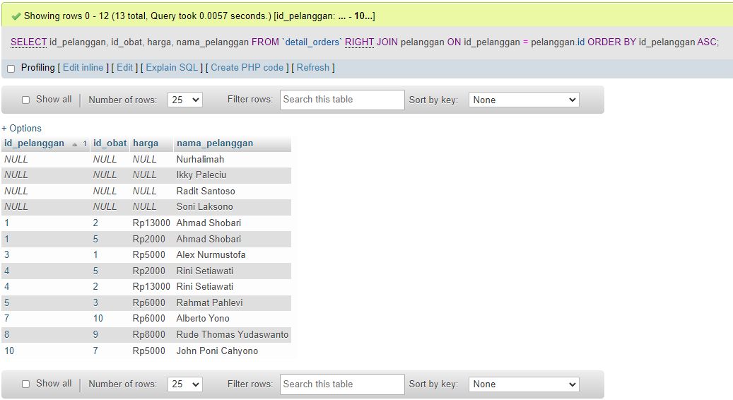

1. SELECT id\_pelanggan, id\_obat, harga, nama\_pelanggan FROM `detail\_orders`

LEFT JOIN pelanggan ON id\_pelanggan = pelanggan.id WHERE id\_obat >=5

